Middlesex County Foundation, Inc.
4-H Camp Middlesex
New Pool Fundraising Campaign

BUY-A-BRICK Order Form

Help Build the New Pool by MAY 2008 …..One Brick at a Time

Now is your chance to support this effort with a one
time donation that will last a lifetime!!

Brick & Engraving Information
- 3 lines per 4 x 8 brick, 6 lines per 8 x 8 brick
- 20 characters per line, (including spaces and punctuation)
- Available brick sizes 4 x 8 inches or 8 x 8 inches
- If you are sponsoring more than one brick, please make
copies of this form or download from www.campmiddlesex.com

Please complete and mail this form to:

Middlesex County Foundation, Inc. Please place your order early!
4-H Camp Middlesex
P.O. Box 185 Any questions, contact Steve LaFountain at 978-386-7704.
Ashby, MA 01431-0185
______________________________________________________________________________________________________________________________
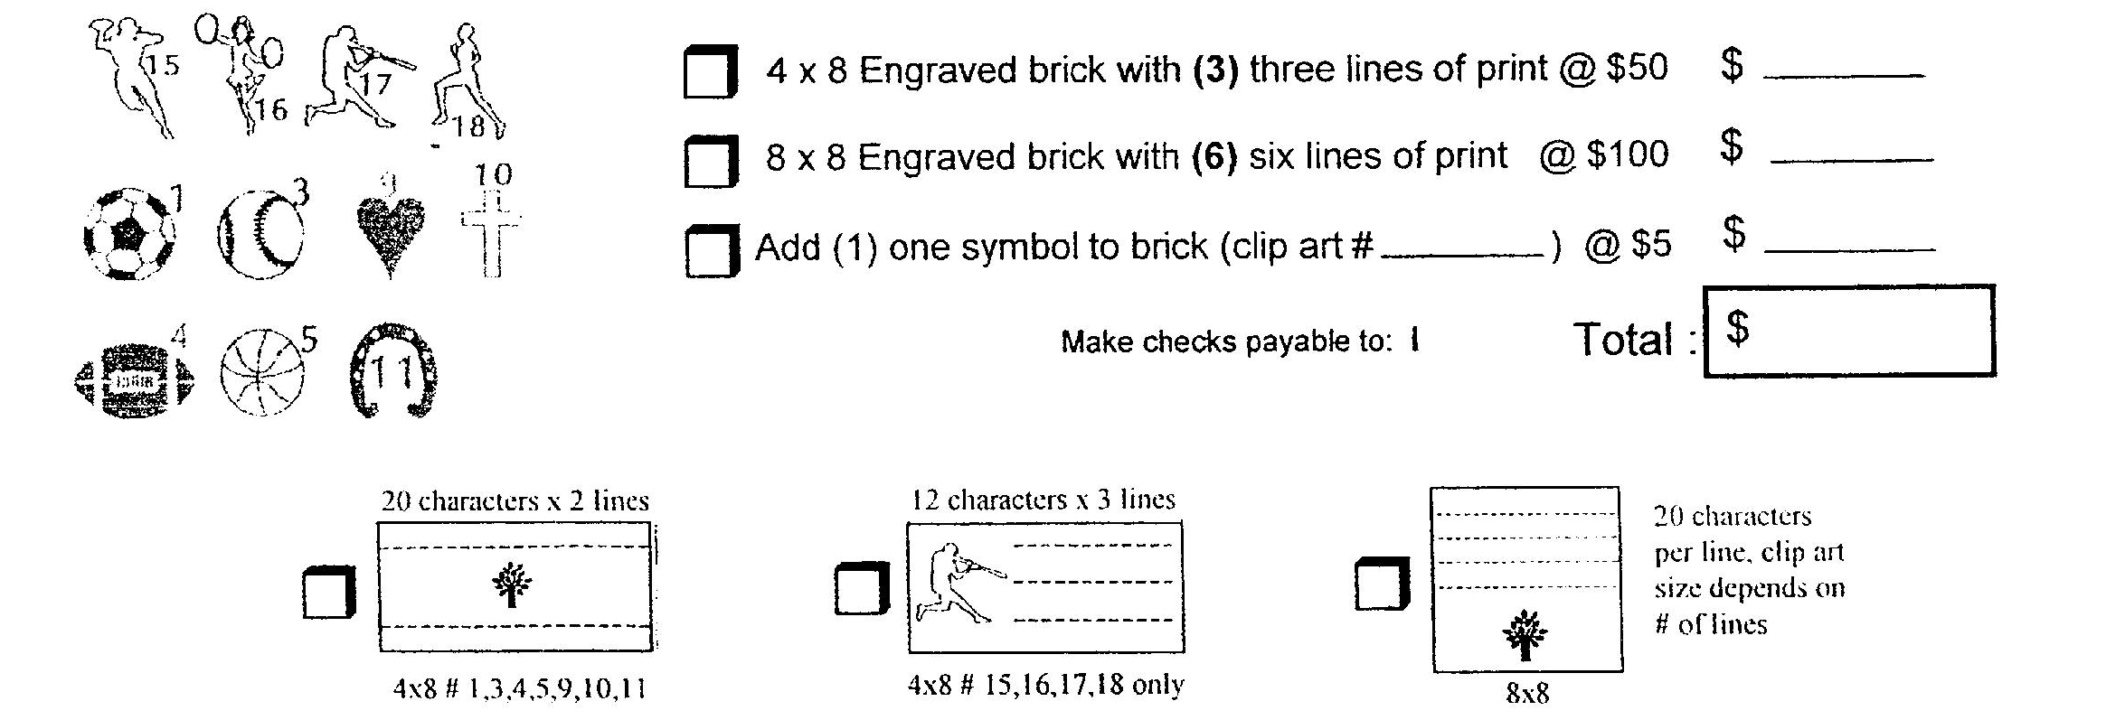
Line 1
Line 2
Line 3
Line 4
Line 5
Line 6

Your Information - PRINT CLEARLY

Name_______________________________ Day Phone ________________________

Address_____________________________ Evening Phone _____________________

City____________ State_____ Zip______ Email_____________________________

