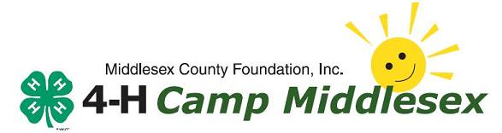
1031 Erickson Road • P.O. Box 185
Ashby, Massachusetts 01431-0185
Phone: (978) 386-7704 • Fax: (978) 386-7046
www.campmiddlesex.com

Camp Store Deposit Form

The camp store at Camp Middlesex is open every day during recreational swim time, from 2:30-3:15. Campers may purchase snacks, drinks, or camp items at the store at this time. The prices of snacks and drinks range from 25 cents to $2. We do not sell any candy at the store. All campers receive an afternoon snack, if desired, at 3:15.

On Wednesday night, overnight campers walk to Ashby Common to watch the band concert. At the common there are snacks on sale for campers to purchase. We recommend that campers be provided with $5 to purchase snacks. All amounts deposited will be distributed to campers at the night of the concert.

Camper’s Name:_________________________________________________________

Cabin/group:_____________ Sessions Registered (circle) 1 2 3 4 5 6 7

At the Camp Store: Enter Amount Here>>

Camp Group Picture at $10.00 Enter Amount
Circle the session(s) you would Here>>>>>>>
like your picture of below:
1 2 3 4 5 6 7

Ashby Band Concert Spending Money Enter Amount
(Recommended $5/week) Here>>>>>>>

Day Camp Only
Ashby Band Concert Dinner at $5 / week
Circle Session(s) 1 2 3 4 5 6 7
Friday Candlelight Dinner at $5 / week Enter Amount
Circle Session(s) 1 2 3 4 5 6 7 Here>>>>>>>

Enter Total
Amount>>>

I wish to donate any unused funds directly to (check one):
Pool Fund Campership Fund Camp

Please REFUND any unused funds

